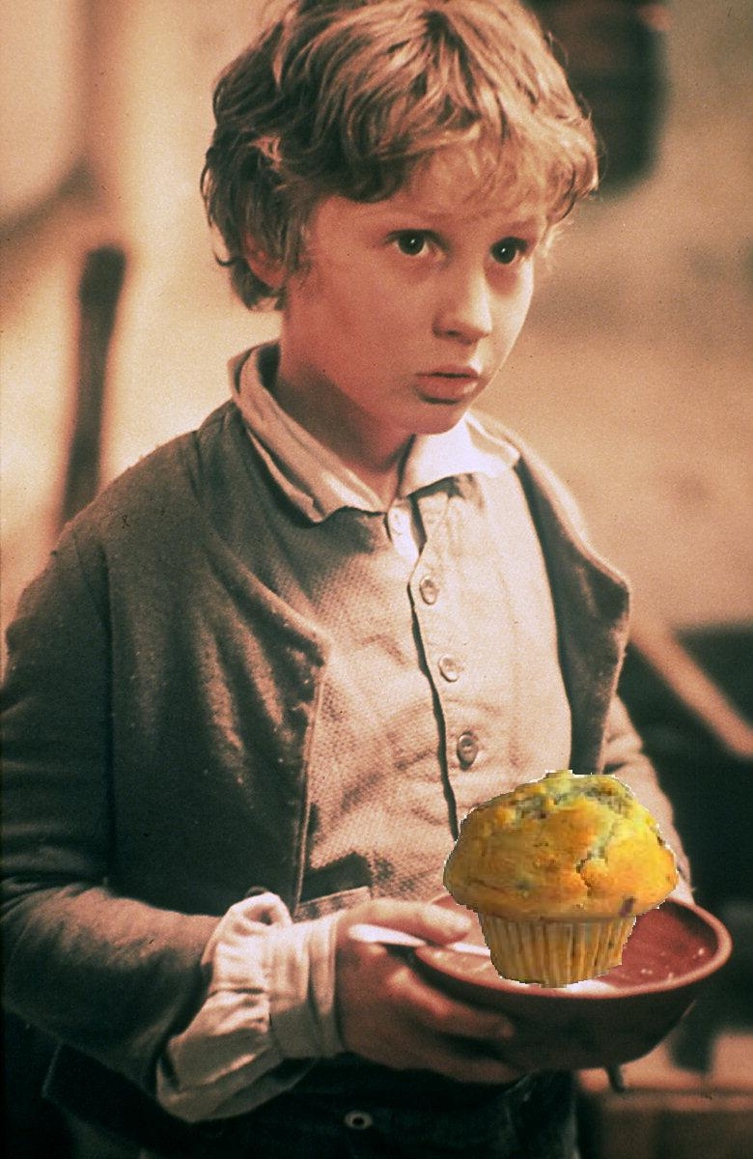
PLEASE SIR, MAY I HAVE SOME MORE CROQUET CLUB MUFFINS?

